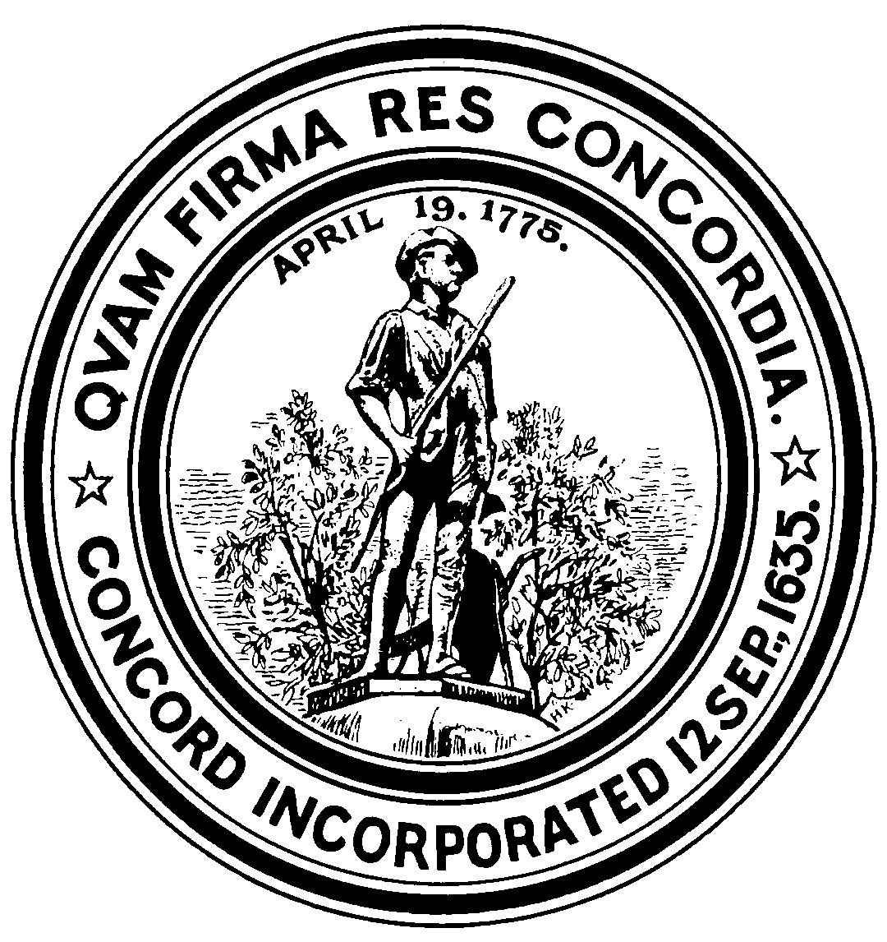

TOWN OF CONCORD

Department of Planning and Land Management

141 Keyes Road - Concord, MA - 01742

PRESS RELEASE
For immediate release: January 9, 2015

Contact: Marcia Rasmussen (978) 318-3290 or mrasmussen@concordma.gov
Director of Planning & Land Management

White Pond Public Forum

On January 21, 2015, the Concord Board of Selectmen will sponsor a Public Forum focused on the White Pond area. There are several purposes of the Forum: to share recent information gathered as part of the White Pond Watershed Management Plan project and the seasonal parking issues study, as well as the current status of the Bruce Freeman Rail Trail design; to clarify community and neighborhood concerns and issues; to obtain public input and ideas of possible solutions; and to clarify the decision making process and identify future actions.

White Pond is an approximately 40-acre ‘Great Pond’ located entirely within the southern portion of
Concord. The pond was briefly described by Henry David Thoreau in Walden, where he characterized White Pond as “the lesser twin of Walden.” Like Walden Pond, White Pond is a natural kettle pond with no perennial surface inlets or outlets. Thoreau went on to describe White Pond as “the gem of the woods”, which has not gone unnoticed by residents, boaters, fisherman, and swimmers turned away from Walden. Development around the pond began in 1931 with the division of land into small lots as summer camp sites. Over time these camp sites were combined and converted into year-round residences. The majority of the White Pond shoreline and watershed is now occupied by year-round residences, although large parcels of undeveloped land are present on the southwestern and eastern ends of the pond. The undeveloped parcels that are owned by the Town were acquired over time for various uses, including water supply, conservation, recreation, wetlands protection, housing and any municipal purpose.

The Selectmen and Town Manager have been hearing from residents over time, as well as members of the White Pond Advisory Committee, and have identified the principal issues for the White Pond area as: 1) water quality, 2) neighborhood impacts and 3) recreational vision and pond stewardship. This Forum will be an opportunity for Concord residents to help confirm and/or expand upon these issues as well as begin to identify and explore some possible solutions.

The White Pond Forum on Wednesday, January 21, 2015 will be held in the auditorium at the Harvey Wheeler Community Center from 6:45 p.m. to 9:00 p.m. An opening panel discussion will begin promptly at 7:00, followed by a brief Q & A session, then small group discussions wrapping up with an opportunity to report to the larger group. For additional information about White Pond and the Public Forum, please visit the Town’s website at www.concordma.gov and the Board of Selectmen’s web page at http://concordma.gov/Pages/ConcordMA_BOS/index.

If you are unable to attend this Forum or have additional comments after the Forum, you are welcome to send your comments by email to Marcia Rasmussen, Director of Planning & Land Management, Town of Concord (mrasmussen@concordma.gov) or to Marcia’s attention c/o DPLM, 141 Keyes Road, Concord, MA 01742 by the end of January.

-end-

